It stores your customer data, gives you processes to nurture prospective customers, and provides ways to collaborate with people you work with. And it does all those things. But saying that Salesforce is “just a CRM” is like saying a house is just a kitchen. There’s a lot more to it than that.

First, it’s important to understand what a **database** is in the context of Salesforce. When we talk about the database, think of a giant spreadsheet. When you put information into Salesforce, it gets stored in the database so you can access it again later. It’s stored in a very specific way so you’re always accessing the information you need.

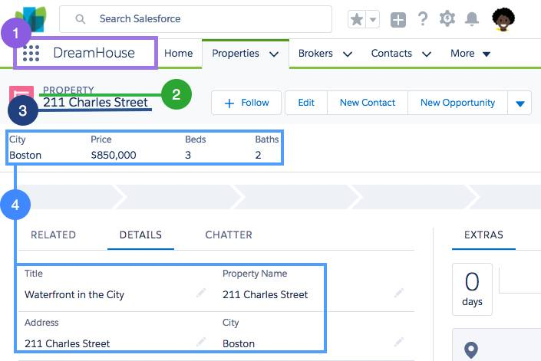

1. An **app** in Salesforce is a set of objects, fields, and other functionality that supports a business process. You can see which app you’re using and switch between apps using the App Launcher ( App Launcher icon).
2. **Objects** are tables in the Salesforce database that store a particular kind of information. There are **standard objects** like Accounts and Contacts and **custom objects** like the Property object you see in the graphic.
3. **Records** are rows in object database tables. Records are the actual data associated with an object. Here, the 211 Charles Street property is a record.
4. **Fields** are columns in object database tables. Both standard and custom objects have fields. On our Property object, we have fields like Address and Price.

A Trailhead Playground (TP) org is a safe environment where you can practice the skills you’re learning before you take them to your real work. TPs come with all the standard app building and customization tools required to test your app development chops. If you’ve ever heard of a Developer Edition (DE) org, a TP is a special type of DE.

You already know that you can use the Salesforce platform to develop custom objects and functionality specific to your business. What you might not know is that you can do most of this development without ever writing a line of code.

Developing without code is known as **declarative development**. With declarative development, you use forms and drag-and-drop tools to perform powerful customization tasks. The platform also offers **programmatic development**, which uses things like Lightning components, Apex code, and Visualforce pages. But if you’re not a programmer, you can still build some amazing things on the platform.

1. From the gear icon ( The gear icon to open Setup.), click **Setup** to launch the setup page. We use Setup a lot, so remember this step!
2. Click the **Object Manager** tab.
3. Click **Contact**.
4. Under Fields & Relationships, click **New**.
5. A data type indicates what kind of information your field holds. For this field, pick Checkbox and click **Next**.
6. The Field Label is what you see on the Contact page. Enter Prequalified? and click **Next**.
7. Click **Next** and then **Save**.

When you’re learning to build on the platform, the first things you want to tackle are projects that have big impact but are easy to implement. While that sounds idealistic, the platform gives you lots of opportunities to make big changes with minimal effort.

Every time you create a custom object, you automatically get something called Chatter feed tracking. Chatter feed tracking provides a way for multiple people to comment and collaborate on a particular record. The discussions and decisions are stored on the record so everyone can stay up to date on important decisions.

By creating a single custom object, you can totally change how your organization collaborates. High impact, low effort. As you start building with the platform, keep your eye out for processes with:

* Heavy email collaboration
* Reliance on spreadsheets
* Shared local documents
* Time-intensive, repetitive manual steps
* Impact on only a few departments (you want to minimize the number of stakeholders while you’re still learning)
* Salesforce is a cloud company. Everything we offer resides in the trusted, multitenant cloud.
* The Salesforce platform is the foundation of our services. It’s powered by metadata and made up of different parts, like data services, artificial intelligence, and robust APIs for development.
* All our apps sit on top of the platform. Our prebuilt offerings like Sales Cloud and Marketing Cloud, along with apps you build using the platform, have consistent, powerful functionality.
* Everything is integrated. Our platform technologies like Einstein predictive intelligence and the Lightning framework for development are built into everything we offer and everything you build.

At Salesforce, **trust** is our top priority. Not only are you keeping your sensitive data in your org, you’re also building functionality vital to your company’s success on our platform. Our responsibility to keep your data and functionality safe is not something we take lightly, which is why we’re always transparent about our services.

 Multitenancy is a great word for making you sound smart at dinner parties, but really all it means is that you’re sharing resources. Salesforce provides a core set of services to all our customers in the multitenant cloud. No matter the size of your business, you get access to the same computing power, data storage, and core features.

 Despite the fact that you’re sharing space with other companies, you can trust Salesforce to keep your data secure. You can also trust that you’re getting the latest and greatest features with automatic, seamless upgrades three times a year. Since Salesforce is a cloud service, you never have to install new features or worry about your hardware. All this is possible because of multitenancy.

**metadata** is data about data. Let’s think about an object like Property. When our friends at DreamHouse use Salesforce, they input and view data about properties. For example, a property can be located in Boston, cost $500,000, and have 3 bedrooms.

Now, imagine you stripped away all that specific data. What are you left with? You are left with the Property object along with all its fields, like address, price, and number of bedrooms. You can also have page layouts, security settings, and any other customizations you’ve made.

All of these standard and custom configurations, functionality, and code in your org are metadata. Part of the reason you can move so fast on the platform is that Salesforce knows how to store and serve you that metadata immediately after you create it.

API: Fundamentally, **APIs** allow different pieces of software to connect to each other and exchange information. Without knowing the details, you can connect your apps with other apps or software systems. The underlying technology takes care of the specifics of how information passes throughout the system.

When you add a custom object or field, the platform automatically creates an API name that serves as an access point between your org and the database. Salesforce uses that API name to retrieve the metadata and data you’re looking for. For example, we can use a contact’s Name field in a bunch of places, like the Salesforce mobile app, a custom page, or even an email template. That’s all possible because of the API name.

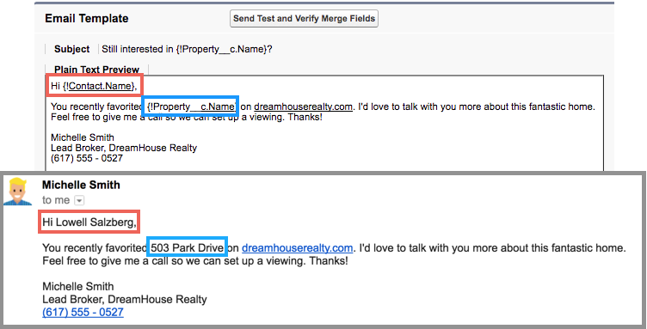

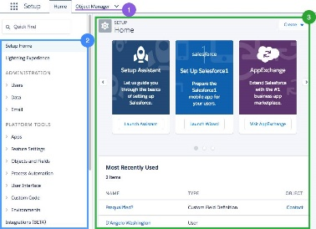**Object Manager:** Object Manager is where you can view and customize standard and custom objects in your org.

**Setup Menu:** The menu gives you quick links to a collection of pages that let you do everything from managing your users to modifying security settings.

**Main Window:** We’re showing you the Setup home page, but this is where you can see whatever it is you’re trying to work on.

There are three main categories in the Setup menu: Administration, Platform Tools, and Settings. Let’s take a look at what’s available.

* **Administration:** The Administration category is where you manage your users and data. You can do things like add users, change permissions, import and export data, and create email templates.
* **Platform Tools:** You do most of your customization in Platform Tools. You can view and manage your data model, create apps, modify the user interface, and deploy new features to your users. If you decide to try your hand at programmatic development, Platform Tools is where you manage your code as well.
* **Settings:** Finally, Settings is where you manage your company information and org security. You can do things like add business hours, change your locale, and view your org’s history.

**App Exchange**: The possibilities AppExchange offers are exciting, but before you start downloading every app in sight you need to develop a strategy. A solid AppExchange strategy helps ensure that you’re getting the highest value apps without duplicating functionality or investing in something that you don’t need.

**Platform building blocks:** The platform not only forms the foundation of core Salesforce products like Sales Cloud and Service Cloud, but it also lets you build your own functionality. Building your own functionality can mean customizing existing Salesforce offerings or it can mean building something from scratch.

Our core platform lets you develop custom data models and applications for desktop and mobile. And with the platform behind your development, you can build robust systems at a rapid pace.

And then there’s the Heroku platform. Heroku gives developers the power to build highly scalable web apps and back-end services using Python, Ruby, Go, and more. It also provides database tools to sync seamlessly with data from Salesforce.

And then there’s the host of Salesforce APIs. These let developers integrate and connect all their enterprise data, networks, and identity information. And then there’s the Mobile SDK. The Mobile SDK is a suite of technologies that lets you build native, HTML5, and hybrid apps that have the same reliability and security as the Salesforce app.